Using Multiple Indicator Cluster Survey (MICS) and Demographic and Health Survey (DHS) data to measure child poverty

David Gordon, Shailen Nandy, Christina Pantazis, Simon Pemberton and Peter Townsend. University of Bristol & London School of Economics, UK.

Introduction
The Multiple Indicator Cluster Surveys (MICS) can be viewed as part of an ongoing data gathering initiative by UNICEF and other international agencies that will help to transform our view of the world over the next few years.

The 1990s witnessed three key international developments which may have laid the foundation for the eradication of poverty during the 21st Century:

- In March 1995, the first World Social Summit in Copenhagen marked a significant political breakthrough in the fight to end world poverty. The largest ever gathering of world leaders (up to that point in time) agreed to make the conquest of poverty, the goal of full employment and the fostering of social integration overriding objectives of development (UN, 1995).

- In December 1995, the General Assembly proclaimed the First United Nations Decade for the Eradication of Poverty (1997-2006). In December 1996, the General Assembly declared the theme for the decade as a whole to be "Eradicating poverty is an ethical, social, political and economic imperative of humankind", thereby helping to generate continued political support for the goal of poverty eradication during the 21st Century.

- Throughout the 1990s a number of international agencies, including the World Bank, USAID, WHO and UNICEF, successfully assisted national governments of developing countries to implement high quality standardised survey instruments (such as the MICs). The results from these surveys are transforming the information base that allows policy makers to both identify priorities for anti-poverty polices and also enable monitoring of the effectiveness of these policies (for example, see Filmer and Pritchett, 1999; 2001; Miljeteig, 1997; Milanovic, 2002; Montgomery et al, 2000; World Bank, 1990; 2000). These are crucial prerequisites for effective policy development and implementation, since both research and experience have demonstrated that no one single set of anti-poverty policies will be effective in all countries – ‘one size does not fit all’ (Townsend and Gordon, 2002; Gordon et al, 2003).

Multiple Indicator Cluster Surveys (MICS)
These household surveys are specifically designed to help countries accurately assess progress for children in relation to the World Summit for Children goals, which were agreed in September 1990 by 71 heads of state and government and 88 other senior officials. There are two groups of MIC surveys: the mid-decade (e.g. mid 1990s) and end-decade surveys, which many countries have carried out with UNICEF’s assistance and advice.

The 1990 World Summit for Children agreed 27 major long term goals, of which a subset of 10 interim goals were selected that were deemed to be achievable by 1995 (Mid-Decade Goals). These goals were endorsed by 153 countries and were based on cost-effective, technology-relevant, high-impact interventions (Vittachi, 1995), including:

- Achieving and sustaining high childhood immunization for the six EPI antigens.
- Raising the use of oral rehydration therapy in the treatment of diarrhoeal dehydration.
- Eradicating dracunculiasis.
- Promoting and protecting breastfeeding.
- Universal salt iodisation.

A serious challenge was the lack of necessary data in many countries which prompted the establishment of a MICS to provide information on Mid-Decade Goal (MDG) indicators.

The mid-decade assessment led to 100 countries collecting data using MICS, household surveys developed to obtain specific mid-decade data, or via MICS questionnaire modules carried by other surveys. By 1996, 60 developing countries had carried out stand-alone MICS and another 40 had incorporated some of the MICS modules into other surveys. Figure 1 shows the distribution of the mid-decade surveys.

Figure 1: Distribution of Mid-Decade Multiple Indicator Cluster Surveys
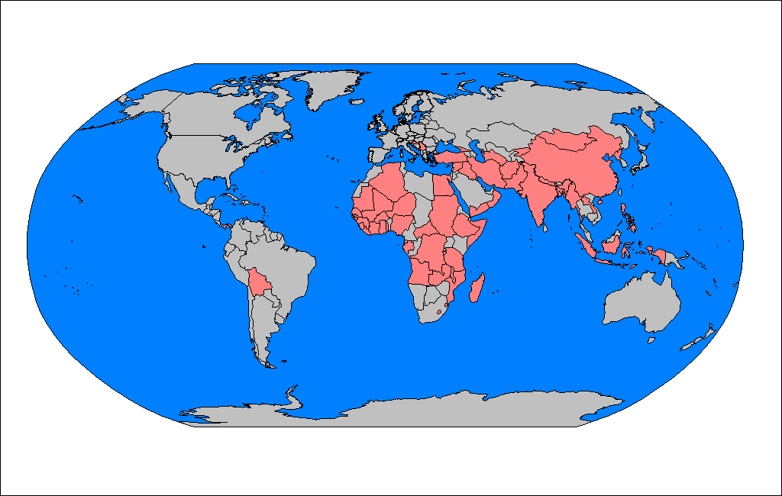
Note: Countries marked in grey on the map had no MIC survey.

The end-decade MIC surveys (sometimes called MICS2) were developed specifically to obtain the data for 63 of the 75 end-decade indicators. These draw heavily on experiences with the mid-decade MICS and the subsequent MICS evaluation (UNICEF, 2000). The MIC surveys are not only essential tools for monitoring progress towards the World Summit for Children goals, they also provide a rich resource for scientific measurements of child poverty and child rights in developing countries (Minujin, 1999; Gordon et al, 2003).

One of the significant innovations of the end-decade MICS2 is that UNICEF have put considerable efforts into making the country and technical reports and the micro-data widely available via the internet to all bone-fide researchers – free of charge. Micro data are currently available from 37 countries and these are shown in Figure 2.

Figure 2: Countries for which MICS2 micro data are currently available to independent researchers
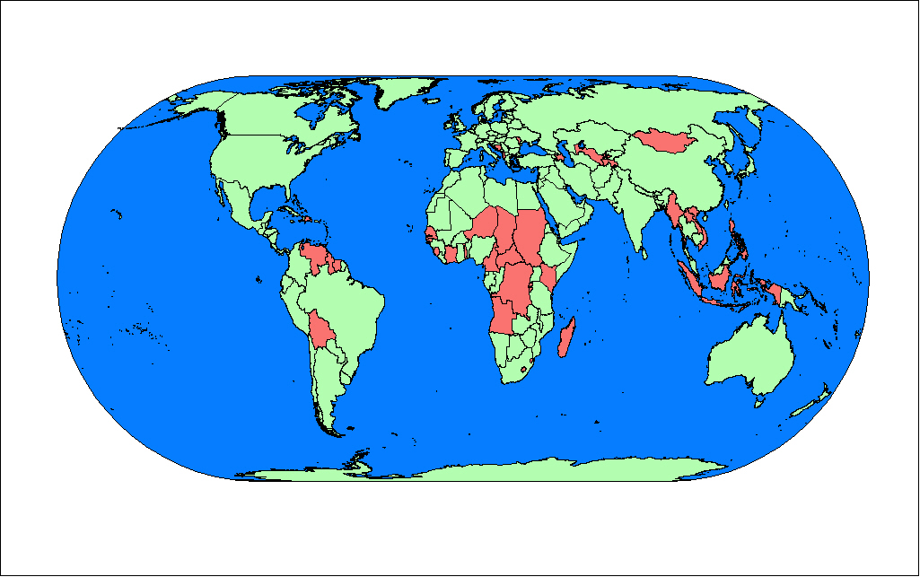
Note: Countries marked in green on the map have no MICS2 data currently available.

Child Poverty
Child poverty is one of the greatest concerns of governments and international organisations. Poverty is a major obstacle for the survival and development of children. Poverty denies the most basic rights of children and its impact often causes permanent damage. Research has shown that, whilst the definitions may vary, all cultures do have a concept and definition of poverty (Gordon and Spicker, 1999). There are currently no consistent estimates of the extent or severity of child poverty in developing countries. Whilst many countries do have detailed anti-poverty strategies and statistics on child poverty, these estimates tend to use different methods and definitions of poverty which makes comparison extremely difficult. The World Bank has not produced any estimates of child poverty using its ‘dollar a day’ thresholds - except for a few countries in Central and South America.

A major problem with many previous attempts to measure poverty on a global scale is that there was no agreed definition of poverty. This situation changed at the Copenhagen World Summit on Social Development (UN, 1995). Among the innovations agreed in the Copenhagen Declaration and Programme of Action was the preparation of national anti-poverty plans based on measures in all countries of ‘absolute’ and ‘overall’ poverty. The aim was to link - if not reconcile - the difference between industrialised and developing country conceptions, allow more reliable comparisons to be made between countries and regions and make easier the identification of acceptable priorities for action (Gordon and Townsend, 2000). In developing anti-poverty strategies, the international agreement at Copenhagen was a breakthrough with the governments of 117 countries agreeing to the two definitions of absolute and overall poverty.

Overall poverty takes various forms, including "lack of income and productive resources to ensure sustainable livelihoods; hunger and malnutrition; ill health; limited or lack of access to education and other basic services; increased morbidity and mortality from illness; homelessness and inadequate housing; unsafe environments and social discrimination and exclusion. It is also characterised by lack of participation in decision-making and in civil, social and cultural life. It occurs in all countries: as mass poverty in many developing countries, pockets of poverty amid wealth in developed countries, loss of livelihoods as a result of economic recession, sudden poverty as a result of disaster or conflict, the poverty of low-wage workers, and the utter destitution of people who fall outside family support systems, social institutions and safety nets.

Women bear a disproportionate burden of poverty and children growing up in poverty are often permanently disadvantaged. Older people, people with disabilities, indigenous people, refugees and internally displaced persons are also particularly vulnerable to poverty. Furthermore, poverty in its various forms represents a barrier to communication and access to services, as well as a major health risk, and people living in poverty are particularly vulnerable to the consequences of disasters and conflicts.”

Absolute poverty was agreed to be "a condition characterised by severe deprivation of basic human needs, including food, safe drinking water, sanitation facilities, health, shelter, education and information. It depends not only on income but also on access to social services."

Income is important but access to public goods – safe water supply, roads, healthcare, education – is of equal or greater importance, particularly in developing countries. There is a need to look beyond income and consumption expenditure poverty measures and at both the effects of low family income on children and the effects of inadequate service provision for children (Vandemoortele, 2000). It is a lack of investment in good quality education, health and other public services in many parts of the world that is as significant a cause of child poverty as low family incomes (Mehrotra et al, 2000; Minujin et al, 2002).

The agreed definition of absolute poverty defines it as a "a condition characterised by severe deprivation of basic human needs.” The two concepts of poverty and deprivation are tightly linked but there is general agreement that the concept of deprivation covers the various conditions, independent of income, experienced by people who are poor, while the concept of poverty refers to the lack of income and other resources which makes those conditions inescapable or at least highly likely (Townsend, 1987).

Deprivation can be conceptualised as a continuum that ranges from no deprivation, through mild, moderate and severe deprivation to extreme deprivation at the end of the scale (Gordon, 2002). Figure 3 illustrates this concept.

Figure 3: Continuum of deprivation

In order to measure absolute poverty amongst children, it is necessary to define the threshold measures of severe deprivation of basic human need for:
- food
- safe drinking water
- sanitation facilities
- health
- shelter
- education
- information
- access to services

Theoretically, we can define ‘severe deprivation of basic human need’ as those circumstances that are highly likely to have serious adverse consequences for the health, well-being and development of children. Severe deprivations are causally related to ‘poor’ developmental outcomes both long and short term. A taxonomy of severe deprivation is required, since a reliable taxonomy is a prerequisite for any scientific measurement. It is also desirable that the threshold measures for severe deprivation, as far as is practicable, conform to internationally agreed standards and conventions. Table 1 shows the idealised operational definitions of deprivation for the eight criteria in the World Summit definition of absolute poverty (from Gordon et al, 2001).

Table 1: Operational definitions of deprivation for children
Deprivation | Mild | Moderate | Severe | Extreme
Food | Bland diet of poor nutritional value | Going hungry on occasion | Malnutrition | Starvation
Safe drinking water | Not having enough water on occasion due to lack of sufficient money | No access to water in dwelling but communal piped water available within 200 meters of dwelling or less than 15 minutes walk away | Long walk to water source (more than 200 meters or longer than 15 minutes). Unsafe drinking water (e.g. open water) | No access to water
Sanitation facilities | Having to share facilities with another household | Sanitation facilities outside dwelling | No sanitation facilities in or near dwelling | No access to sanitation facilities
Health | Occasional lack of access to medical care due to insufficient money | Inadequate medical care | No immunisation against diseases. Only limited non-professional medical care available when sick | No medical care
Shelter | Dwelling in poor repair. More than 1 person per room | Few facilities in dwelling, lack of heating, structural problems. More than 3 people per room | No facilities in house, non-permanent structure, no privacy, no flooring, just one or two rooms.  More than 5 persons per room | Roofless – no shelter
Education | Inadequate teaching due to lack of resources | Unable to attend secondary but can attend primary education | Child is 7 or older and has received no primary or secondary education | Prevented from learning due to persecution and prejudice
Information | Can’t afford newspapers or books | No television but can afford a radio | No access to radio, television or books or newspapers | Prevented from gaining access to information by government, etc.
Basic Social Services | Health and education facilities available but occasionally of low standard | Inadequate health and education facilities near by (e.g. less than 1 hour travel) | Limited health and education facilities a days travel away | No access to health or education facilities

It is rarely (if ever) possible to perfectly implement idealised definitions (such as those in Table 1 above) using survey data that were collected for other purposes. Some compromise always has to be made when dealing with survey data. In our previous research, we have demonstrated that Demographic and Health Survey (DHS) data can be used to produce measures of severe deprivation for children which are conceptually very close to our idealised measures (see Gordon et al, 2003). In this paper, we show how the idealised definitions of severe deprivation in Table 1 can be operationalised using MICS2 data – the key question numbers used to measure severe deprivation from the MICS2 model questionnaires are shown in brackets and the SPSS syntax for each country is available from the authors.

- Severe Food Deprivation– children whose heights and weights for their age were more than -3 standard deviations below the median of the international reference population, i.e. severe anthropometric failure
(Anthropometry Module Q1, Q2 and Childs Age) .

- Severe Water Deprivation - children who only had access to surface water (e.g. ponds, rivers or springs) for drinking or who lived in households where the nearest source of water was more than 15 minutes away.
(Water and Sanitation Module Q1, Q2)

- Severe Deprivation of Sanitation Facilities – children who had no access to a toilet of any kind in the vicinity of their dwelling, including communal toilets or latrines.
(Water and Sanitation Module Q3, Q4)

- Severe Health Deprivation – children who had not been immunised against any diseases or young children who had a recent illness causing acute respiratory infection (ARI) and had not received any medical advice or treatment. (Immunization Module Q1 to Q9 Care of Illness Module Q6 to Q10)

- Severe Shelter Deprivation – children living in dwellings with more than five people per room (severe overcrowding) or with no flooring material (e.g. a mud floor). (Household Information Module Q8, Q9)

- Severe Education Deprivation – children aged between 7 and 18 who had never been to school and were not currently attending school (no professional education of any kind). (Education Module Q15)

- Severe Information Deprivation – children aged between 3 and 18 in households which do not possess a radio, television, telephone or computer. (Socio-economic Status Module question on radio, television, computers and telephone – where present)

Children who suffer from these levels of severe deprivation are very likely to be living in absolute poverty because, in the overwhelming majority of cases, the cause of severe deprivation of basic human need is invariably a result of lack of resources/income. However Gordon and his colleagues (2003) have argued that there may also be some children in this situation due to discrimination, (particularly girls suffering severe education deprivation) or due to disease (severe malnutrition can be caused by some diseases). For this reason, we have assumed that a child is living in absolute poverty in the MICS2 surveys only if he or she suffers from multiple deprivations (i.e. two or more severe deprivations of basic human need as defined above).

The purpose of this study was to measure children’s living conditions that were so severely deprived that they were indicative of absolute poverty. Thus, the measures used represent more severe deprivations than the indicators frequently published by international organisations. For example, ‘no schooling’ instead of ‘non-completion of primary school’, ‘no sanitation facilities’ instead of ‘unimproved sanitation facilities’, ‘no immunisations of any kind’ instead of ‘incomplete immunisation against common diseases’, etc.

We have, in the tradition of Seebohm Rowntree (1901), tried to err on the side of caution in defining these indicators of absolute poverty in such severe terms that few would question that these living conditions were unacceptable. There is not sufficient space available in the paper to go into the background details of how and why each indicator of severe deprivation of basic human need was defined. However, the example of severe shelter deprivation is given below as Gordon and his colleagues (2003) found that more than half a billion children (34%) in the developing world lived in dwellings with more than five people per room or which had mud flooring.

Severe Shelter Deprivation
The operational definition of severe shelter deprivation for children has two components. As discussed above, a ‘deprivation’ can be defined as an item or activity of insufficient quality and/or quantity compared with the norms of a child’s society. Thus, water deprivation is having an insufficient quantity and/or quality of water, food deprivation is having an insufficient quantity and/or quality of food and shelter deprivation is having an insufficient quantity and/or quality of shelter, and so on.

A child is defined as severely shelter deprived if they either live in:

- a crowded dwelling (more than five people per room) – an indicator of severe quantity deprivation; or

- a dwelling in which the rooms have mud or dirt flooring – an indicator severe quality deprivation..

Crowding
The use of crowding (or overcrowding as it is sometimes called) as an indicator of shelter deprivation that is highly correlated with poverty, originated from the pioneering research of Charles Booth in the 19th Century. Booth undertook the first comprehensive scientific survey of poverty and living conditions in London, England. Work started in the autumn of 1886 and lasted 17 years with the results being published in 28 volumes between 1889 and 1903 (Stone, 1997). Booth divided the population of London into eight classes, from A ‘lowest class’ (vicious semi-criminal poor, loafers, homeless, street vendors) to H ‘upper middle class’ (professionals with servants). People in classes A and B were considered to be ‘very poor’, those in class C and D ‘poor’ and those in classes E to H were living ‘in comfort’. Booth wished to check that he had got the apportionment of the population among his eight classes correct so, at his suggestion, a question was included in the 1891 National Population and Housing Census about crowded household conditions (Stone, 1997). Booth (1893) found that 4.6% of the 4.2 million people in London were living in very crowded conditions of four or more people per room and that 31.5% were living in crowded conditions (defined as two or more people per room).

Booth (1895) argued that:

“A man and his wife and one child, or a widow with two children may occupy only one room; or a family of six or seven may have only two rooms; and yet not be “very poor” in the sense of suffering “chronic want”. But when four or more persons live in one room or eight or more in two rooms, there must be great discomfort, and want of sufficient food, clothing, and firing must be a frequent incident. I have therefore drawn the line at this point, and find 188,000 people who are undoubtedly very poor. Further, of the 300,000 people who live three or from three to four in a room, it may be that half would correctly be placed in the same category. If so, we have 340,000 in all of “very poor” amongst the crowded, a number which compares closely with the 350,000 of the old classification.”

The problems for children that are a result of severe crowding, such as an increased risk of fire (firing) and accidents, that Booth described in 1895 are unfortunately still the same today (UNICEF, 2002).

In this research, we have defined severe housing quantity deprivation as more than five people per room thus we have erred on the side of caution by using a much harsher definition of crowding than that used by Charles Booth to estimate the number of ‘very poor’ people living in the worst slum conditions of 19th Century London.

Mud flooring
A mud floor represents a good indicator of severe deprivation of shelter quality for children as:

- Children spend much more time than adults sitting, walking and playing on the floor.

- Children take several years to gain control over their own continence and mud floors can be hard to clean and keep hygienic.

- Particularly in areas like South Asia which can have heavy rains (monsoon), a wet mud floor is not a good place for a baby to be crawling or for a toddler to try to learn to walk or for older children to play.

- Mud floors can cause sanitation problems (particularly for children) especially when there is limited water available for washing, e.g. children playing on a mud floor will likely pick up more harmful pathogens than on a concrete or wood floor. Hard to clean floors increase contact with pathogens especially for babies and young children. (Bartlett et al, 1999; UNICEF, 2002)

- The presence of mud floors is easy to ascertain and it is a widely used indicator of a low standard of living . Mud floors also correlate highly with other indicators of ‘very poor’ quality housing such as an inadequate roof.

We know of no countries in the world where the building regulations consider it acceptable for children to live in dwelling with a mud or dirt floor.

Combining MICS2 and DHS Data
The MICS2 survey data are sufficient to produce accurate and reliable estimates on the extent of severe deprivation and absolute poverty at individual country level. However, there are not yet sufficient data available from the MICS2 surveys to produce a reliable estimate on the extent of absolute poverty and severe deprivation for children in the developing world as a whole. However, by combining MICS2 data with DHS survey data, such an estimate is possible for the developing world today and planet-wide estimates will become possible in the near future. Combining MICS2 and DHS survey data has two main advantages:

- In a combined data set, an increased number of countries are available for analyses compared with analyses of just DHS or MICS2 surveys on their own.

- By combining MICS2 and DHS survey data on the same countries, a much larger sample becomes available for analysis thereby reducing the extent of random survey errors.

However, the main disadvantage of combining MICS2 and DHS surveys in a single analysis is that there are some (relatively small) definitional and operational differences between the two survey instruments. This is not surprising given that the primary purpose of the MICS2 surveys is to assess progress for children at end-decade in relation to the World Summit for Children goals, whereas the primary purpose of the DHS is to produce monitoring and impact evaluation indicators in the areas of population, health, and nutrition. However, during the development phase of the end-decade MICS questionnaire and manual, UNICEF undertook a wide consultation exercise with many organisations including the DHS development team and this has resulted in a high degree of comparability between these two survey instruments. Figure 4 shows the countries for which DHS micro-data are currently available.

Figure 4: Distribution of Demographic and Health Surveys
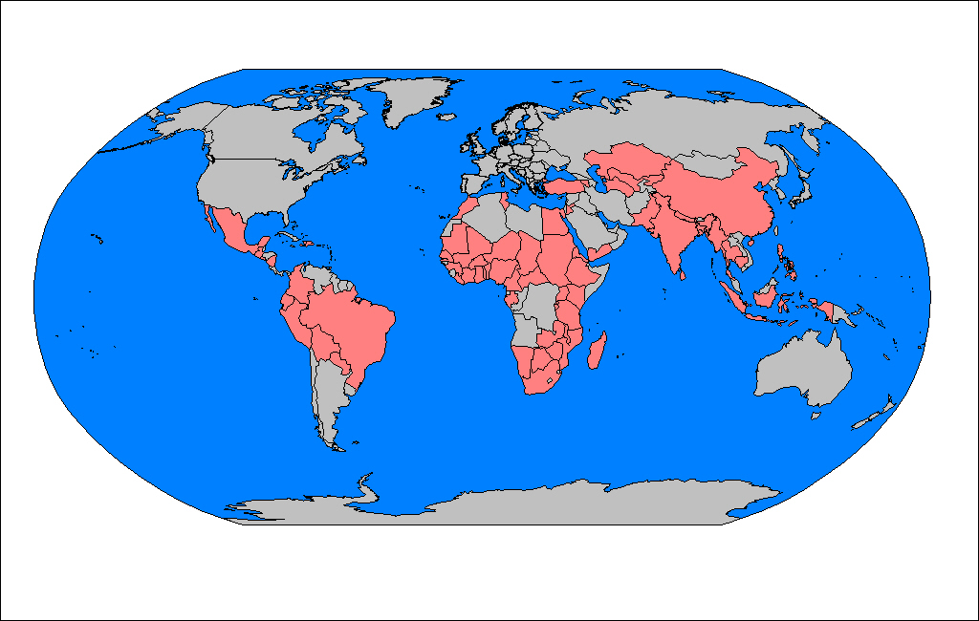
Note: Chinese data is from the National Sample Survey on the Situation of Children.

Figure 5 below shows an example of the comparability between the 1998 DHS survey and the 2000 MICS2 survey in Kenya when used to measure severe deprivation of basic human needs and absolute poverty amongst children. These two surveys were of similar size – 8,380 households were interviewed in the DHS survey and 8,993 households were interviewed in the MICS2 survey.

Figure 5: Comparison of the Kenya DHS (1998) and MICS2 (2000)
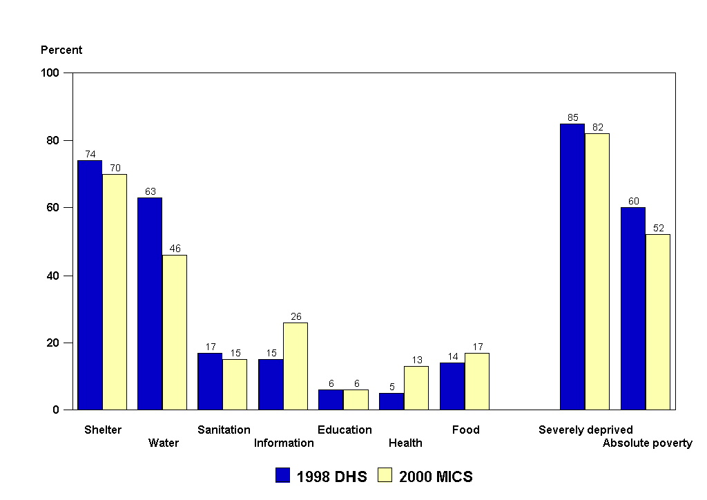

The prevalence estimates of the amount of shelter, sanitation, education and food deprivation are all within 5% of each other - as measured by the two different surveys. There are larger differences in both information and food deprivation which are a result of definitional differences in the surveys. The DHS survey includes questions on both possession of information systems (radio, television, newspapers, etc) and also on the access of women in the household to these information systems both in and outside the household (for example, if they watch a communal television). By contrast, the MICS2 survey instrument does not ask about either the purchase of newspapers or about access to communal television and radios outside the home. This results in a 9% higher estimate of the extent of information deprivation in the MICS2 survey of Kenya compared with the DHS. Similarly, the Kenyan MICS2 survey measures untreated Acute Respiratory Infections (ARI) whereas the DHS measures untreated diarrhoeal disease and this results in the 8% differences in prevalence rates for health deprivation. However, the 18% difference in water deprivation prevalence rates between the MICS2 survey estimate (46% water deprived) and the DHS estimate (63% water deprived) cannot be explained by definitional differences.

The questions on the source of the household’s water supply are effectively identical in the two surveys yet 28% of households in the Kenyan MICS2 survey in 2000 said that their main source of water was a ‘river, pond or stream’ compared with 43% of households that gave this answer in the 1998 Kenyan DHS. Since we are unable to resolve these differences, we have not at present tried to combine DHS and MICS2 data for the same countries. The combined analyses reported below build on the research of Gordon and his colleagues (2003) by adding MICS2 survey data for countries where there are currently no DHS data available.

By combining the results from both MICS2 and DHS surveys and the similar National Sample Survey on the Situation of Children in China, it is possible to produce a very large and representative sample of children in which the information about their lives was reported by their mothers or main carers. High quality household and individual survey data are available from 70 countries (see Table 2 and Appendix I), collected within the ten year period 1991 to 2001. The total number of children in this aggregated sample was over 2.4 million (approximately one in every 775 children in the developing world, excluding the high income countries). This is the largest and most accurate survey sample of children ever assembled and contains information on approximately twice as many children as the data analysed by Gordon and his colleagues (2003). It is a particularly good sample of sub-Saharan African children (with interview data on more than one child in every 500) although the number of children in the South Asia sample (318,361) represents a lower sampling fraction (one child in every 1,758). Nevertheless, the South Asian sample is both very large and highly representative of the circumstances of children in the region.

Table 2: Summary of available sample size details, by region
Region | Number of children in aggregated sample | Number of children under 18  (UN figures, 2000) | Sampling Fraction | Number of countries with survey data
Latin America & Caribbean | 189,709 | 193,283,000 | 1 in 1,018 | 12
Middle East North Africa | 196,850 | 151,854,000 | 1 in 771 | 4
South Asia | 318,361 | 559,615,000 | 1 in 1,758 | 4
East Asia & Pacific | 939,662 | 590,621,000 | 1 in 629 | 8
Central and West Asia | 65,829 | 55,481,000 | 1 in 843 | 7
Sub-Saharan Africa | 656,313 | 317,860,000 | 1 in 484 | 35
World total | 2,412,191 | 1,868,714,000 | 1 in 775 | 70
Note: Industrialised and High Income countries have been excluded from the Table.

Severe shelter and severe sanitation deprivation are the problems affecting children in the developing world, with more than half a billion living in dwellings with more than five people per room or which have mud flooring. Over half a billion children (31%) also have no toilet facilities whatsoever.

More than one in five children (nearly 400 million) are using unsafe open water sources (rivers, ponds, lakes, etc.) or have more than a 15 minute walk to fetch water. Over 300 million children (17%) lack access to radio, television, telephone, newspapers or computers at home or in their communities.

In the developing world, over 16% of children under five years old are severely malnourished and over half of these (91 million children) are in South Asia. Around 265 million children (16%) have not been immunised against any diseases or have had a recent illness causing diarrhoea or acute respirator infection and have not received any medical advice or treatment. Lastly, 134 million children aged between 7 and 18 (14%) are severely educationally deprived - they have never been to school.

There are differences both between and within regions (see Table 3). Sub-Saharan Africa has the highest rates of severe deprivation with respect to five of the seven indicators - severe shelter, water, information, educational and health deprivation. However, within the region, severe water deprivation ranges from 19% to 90%.

Figure 6: Percent of children severely deprived of basic human needs in developing countries
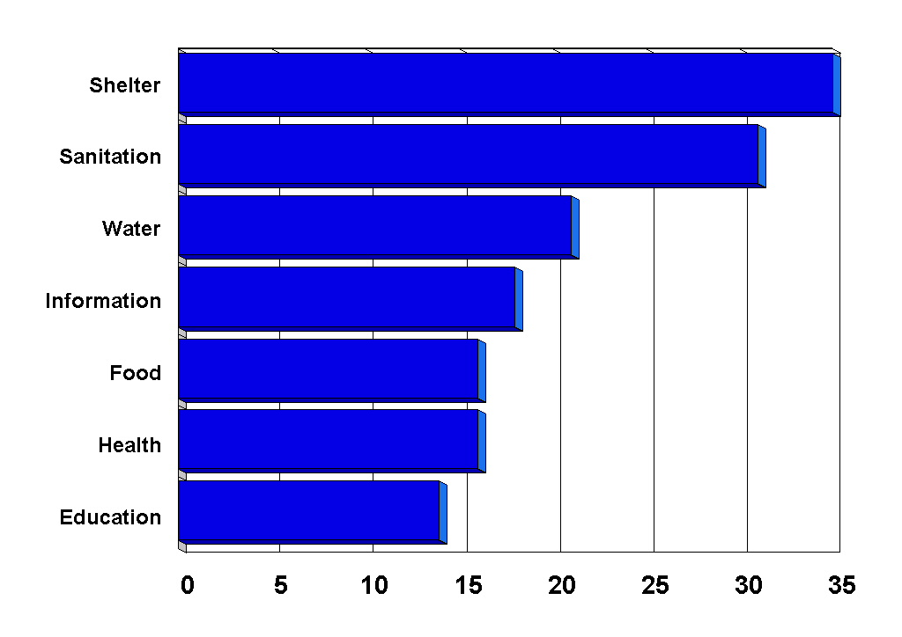

Table 3: Percent of children living in poverty and severe deprivation, by region
Region | Absolute Poverty  (2+ severe deprivations) | Severely Deprived  (1+ severe deprivations) | Shelter | Sanitation | Information | Water | Food | Health | Education
Sub Saharan Africa | 63 | 82 | 64 | 35 | 29 | 53 | 19 | 30 | 29
South Asia | 54 | 81 | 45 | 61 | 28 | 18 | 24 | 23 | 19
Middle East & North Africa | 40 | 67 | 54 | 28 | 9 | 23 | 16 | 17 | 23
Latin America & Caribbean | 15 | 32 | 21 | 16 | 5 | 7 | 5 | 7 | 3
East Asia & Pacific | 9 | 31 | 10 | 10 | 6 | 13 | 12 | 5 | 4
Central & West Asia | 8 | 30 | 16 | 1 | 4 | 14 | 7 | 2 | 6
Developing World | 35 | 58 | 35 | 31 | 17 | 21 | 16 | 16 | 14
Note: Percentages for Health and Food Deprivation are for the population aged under 5 and, for Education Deprivation, it is for the population aged 7 to 18. Information Deprivation is for the child population aged 3 to 18 and access to communal TVs and other information facilities have been included.

Conclusions
Anti-poverty strategies need to respond to local conditions - blanket solutions for the eradication of child poverty are likely to be unsuccessful given the differences in the extent and nature of severe deprivation between and within developing countries. This research indicates that considerably more emphasis needs to be placed on improving basic infrastructure and social services for families with children, particularly with regards to shelter and sanitation in rural areas. An international investment fund for payment towards national schemes of child benefit in cash or kind would help to provide the impetus for rapid fulfilment of children's fundamental rights to social security and an adequate standard of living.

Our results for children show that severe deprivation of basic human need for physical capital (e.g. clean water, sanitation, housing) is a more prevalent problem than severe human capital deprivation (e.g. education, health services and malnutrition). This finding has significant policy implications as tackling physical capital problems may be a pre-requisite for successful human capital interventions, e.g. feeding programmes and health and education service interventions will only have limited success if malnutrition and disease is being caused by a lack of sanitation, clean water and squalid housing conditions.

References
Bartlett, S., Hart, R., Satterthwaite, D., de la Barra, X. and Missair, A. (1999), Cities for Children: Children’s Rights, Poverty and Urban Management, Earthscan, London.
Ben-Arieh, A. and Wintersberger, H. (1997) (Eds) Monitoring and measuring the state of children - beyond survival, Eurosocial Report 63, European Centre: Vienna.
Booth, C. (1893) Life and Labour of the People in London: first results of an inquiry based on the 1891 Census. Journal of the Royal Statistical Society, Vol LIV, Pt IV, 600-643.
Booth, C. (1895) Life and Labour of the People in London: Industry Volume V. London Macmillian.
Filmer, D. and Pritchett, L. (1999) The effect of household wealth on educational attainment: evidence from 35 countries, Population and Development Review, 25(1), 85-120.
Filmer, D. and Pritchett, L. (2001) Estimating wealth effects without expenditure data or tears: an application to educational enrollments in states of India. Demography, 38(1), 115-32.
Gordon, D. (2002) ‘The international measurement of poverty and anti-poverty policies’ in P. Townsend and D. Gordon (Eds) World Poverty: New policies to defeat an old enemy. The Policy Press: Bristol.
Gordon, D. and Spicker, P. (Eds) (1999) The International Glossary on Poverty, Zed Books: London.
Gordon, D. and Townsend, P. (Eds) (2000) Breadline Europe: The Measurement of Poverty, The Policy Press: Bristol.
Gordon, D., Nandy, S., Pantazis, C., and Townsend, P. (with Minujin, A., Vandemoortele, J. and Namazie, C.) (2001) Child Rights and Child Poverty in Developing Countries, University of Bristol: Bristol.
Gordon, D., Nandy, S., Pantazis, C., Pemberton, S. and Townsend, P. (2003) Child Poverty in the Developing World, The Policy Press: Bristol.
Mehrotra, S., Vandemoortele, J.and Delamonica, E. (2000) Basic Services for All? Public Spending and the Social Dimensions of Poverty. UNICEF Innocenti Research Centre: Florence, Italy.
(Available from http://www.unicef-icdc.org/publications/pdf/basice.pdf)
Milanovic, B. (2002) True World Income Distribution, 1988 and 1993: First Calculations Based on Household Surveys Alone, The Economic Journal 112: 51-92.
Miljeteig, P. (1997) ‘The international effort to monitor children's rights’ in A. Ben-Arieh and H. Wintersberger (Eds) Monitoring and measuring the state of children - beyond survival, Eurosocial Report 63, European Centre: Vienna, pp55-62.
Minujin, A. (1999) Putting Children into Poverty Statistics. Paper presented at the Third Meeting of the Expert Group on Poverty Statistics (Rio Group), INE, Lisbon, Portugal, 22nd to 24th November, 1999.
Minujin, A., Vandemoortele, J. and Delamonica, E. (2002) Economic growth, poverty and children. Environment & Urbanization, Vol 14, No 2, 23-43.
(http://www.ucl.ac.uk/dpu-projects/drivers_urb_change/urb_society/pdf_liveli_vulnera/IIED_minujin_poverty.pdf)
Montgomery, M., Gragnolati, M., Burke, K. and Paredes, E. (2000) Measuring living standards with proxy variables, Demography, 37(2): 155-74.
Rowntree, B.S. (1901) Poverty. A Study of Town Life. Macmillan: London. Recently re-published in 2000 by The Policy Press
(see http://www.bris.ac.uk/Publications/TPP/pages/at036.htm)
Stone, R. (1997) Some British Empiricists in the Social Sciences 1650-1900. Cambridge, Cambridge University Press.
Townsend, P. (1987) Deprivation, Journal of Social Policy 16(2) 125-146.
Townsend, P. and Gordon, D. (Eds) (2002) World Poverty: New policies to defeat an old enemy. The Policy Press: Bristol.
UNICEF (2000) Poverty Reduction Begins with Children. UNICEF: New York.
(http://www.unicef.org/publications/index_5616.html)
UNICEF (2002) Poverty And Exclusion Among Urban Children Innocenti Digest No 10, Florence, Innocenti Research Centre.
(http://www.unicef-icdc.org/publications/pdf/digest10e.pdf)
United Nations (1995) The Copenhagen Declaration and Programme of Action: World Summit for Social Development 6-12 March 1995, United Nations Department of Publications: New York.
(http://www.un.org/esa/socdev/wssd/agreements/index.html)
Vandemoortele, J. (2000) Absorbing Social Shocks, Protecting Children and Reducing Poverty: The Role of Basic Social Services, UNICEF Working Paper EPP-00-001: New York.
(http://www.unicef.org/evaldatabase/Global_2000_Absorbing_Social_Shocks.pdf)
Vittachi S (1995) Mid-Decade Goals and National Action Plans, International Child Health 6(4): 2-6.
World Bank (1990) World Development Report 1990: Poverty, Washington DC: World Bank.
World Bank (2000), World Development Report 2000/2001: Attacking Poverty, New York and Oxford: Oxford University Press.
(http://www.worldbank.org/poverty/wdrpoverty/)

Appendix I: Available high quality survey data on children, 1991-2001

Region | Number of children in dataset
Central & West Asia | 65,829
Sub-Saharan Africa | 656,313
Middle East & North Africa | 196,850
Latin America & Caribbean | 235,176
South Asia | 318,361
East Asia | 939,662
Total | 2,412,191
Central and West Asia | Number of children in dataset | Source
Armenia | 8,281 | DHS
Azerbaijan | 9,732 | MICS
Kazakhstan | 5,728 | DHS
Kyrgyzstan | 7,016 | DHS
Tajikistan | 12,711 | MICS
Turkey | 13,940 | DHS
Uzbekistan | 8,421 | DHS
Total | 65,829
Latin America | Number of children in dataset | Source
Bolivia | 25,933 | DHS
Brazil | 22,719 | DHS
Colombia | 17,996 | DHS
Dominican Republic | 21,541 | DHS
Guatemala | 16,424 | DHS
Guyana | 8,733 | MICS
Haiti | 12,324 | DHS
Nicaragua | 33,886 | DHS
Peru | 56,572 | DHS
Suriname | 6,603 | MICS
Trinidad & Tobago | 4,983 | MICS
Venezuela | 7,462 | MICS
Total | 235,176
South Asia | Number of children in dataset | Source
Bangladesh | 27,221 | DHS
India | 237,902 | DHS
Nepal | 26,298 | DHS
Pakistan | 26,940 | DHS
Total | 318,361
Sub-Saharan Africa | Number of children in dataset | Source
Angola | 16,535 | MICS
Benin | 15,349 | DHS
Burkina Faso | 22,541 | DHS
Burundi | 11,656 | MICS
Cameroon | 13,320 | DHS
Central African Republic | 14,278 | DHS
Chad | 21,098 | DHS
Comoros | 7,350 | DHS
Dem Rep Congo | 30,386 | MICS
Ivory Coast | 19,972 | DHS
Ethiopia | 34,142 | DHS
Gambia | 14,191 | MICS
Ghana | 11,500 | DHS
Guinea | 19,188 | DHS
Guinea-Bisseau | 18,282 | MICS
Kenya | 20,215 | DHS
Lesotho | 14,352 | MICS
Madagascar | 18,011 | DHS
Malawi | 13,590 | DHS
Mali | 27,791 | DHS
Mauritania | 18,719 | DHS
Mozambique | 23,508 | DHS
Namibia | 14,025 | DHS
Niger | 20,893 | DHS
Nigeria | 20,265 | DHS
Rwanda | 21,215 | DHS
Senegal | 30,009 | DHS
Sierra Leone | 11,541 | MICS
South Africa | 28,376 | DHS
Swaziland | 12,575 | MICS
Tanzania | 9,786 | DHS
Togo | 24,257 | DHS
Uganda | 21,055 | DHS
Zambia | 21,685 | DHS
Zimbabwe | 14,657 | DHS
Total | 656,313
Middle East & North Africa | Number of children in dataset | Source
Egypt | 52,250 | DHS
Morocco | 18,845 | DHS
Sudan | 76,639 | MICS
Yemen | 49,116 | DHS
Total | 196,850
East Asia & Pacific | Number of children in dataset | Source
Cambodia | 34,555 | DHS
China (NSSC dataset) | 666,872 | NSSC
Indonesia | 101,535 | DHS
Lao | 19,394 | MICS
Mongolia | 14,478 | MICS
Myanmar | 51,645 | MICS
Philippines | 36,426 | DHS
Viet Nam | 14,757 | MICS
Total | 939,662

See http://www.un.org/esa/socdev/poverty/poverty.htm
see http://www.unicef.org/wsc/
see http://www.childinfo.org/eddb/index.htm
see http://www.childinfo.org/MICS2/finques/M2finQ.htm
see MICS2 Appendix at http://www.childinfo.org/MICS2/finques/gj00107.pdf for discussion.
See http://www.childinfo.org/MICS2/Gj99306m.htm
See http://www.cpirc.org.cn/en/datalist.htm
This preliminary analyses is based on the 52 most populous countries in the combined DHS & MICS2 survey data.
The percentage and numbers of children who are severely information deprived reported in this paper are fewer than in Gordon et al (2003) as access to communal televisions and other information facilities have been included in this analysis. This change in particular significantly reduces the estimated extent of information poverty in South Asia.

